Recursive Distinctioning as a Context for Thinking about Processes

By Louis H. Kauffman and Joel Isaacson

I. A Quick Introduction to Recursive Distinctioning.
Recursive Distinctioning (RD) means just what it says. A pattern of distinctions is given in a space based on a graphical structure (such as a line of print or planar lattice or given graph). Each node of the graph is occupied by a letter from some arbitrary alphabet. A specialized alphabet is given that can indicate distinctions about neighbors of a given node. The neighbors of a node are all nodes that are connected to the given node by edges in the graph. The letters in the specialized alphabet (call it SA) are used to describe the states of the letters in the given graph and at each stage in the recursion, letters in SA are written at all nodes in the graph, describing its previous state. The recursive structure that results from the iteration of descriptions is called RD. Here is an example. We use a line graph and represent it just as a finite row of letters. The Special Alphabet is SA = {=, [, ], O} where “=” means that the letters to the left and to the right are equal to the letter in the middle. Thus if we had AAA in the line then the middle A would be replaced by =. The symbol “[” means that the letter to the LEFT is different. Thus in ABB the middle letter would be replaced by [. The symbol “]” means that the letter to the right is different. And finally, the symbol “O” means that the letters both to the left and to the right are different. SA is a tiny language of elementary letter-distinctions. Here is an example of this RD in operation where we use the proverbial three dots to indicate a long string of letters in the same pattern. For example,
... AAAAAAAAAABAAAAAAAAAA ... is replaced by
... =========]O[========= ... is replaced by
... ========]OOO[======== ... is replaced by
... =======]O[=]O[======= ... .
Note that the element ]O[ appears and it has replicated itself in a kind of mitosis. To see this in more detail, see the output from a mathematica program written by LK that uses a blank or unmarked state instead of the = sign. Elementary RD patterns are fundamental, and they will be found in many structures at all levels. There is also a cellular automaton example of this phenomenon. Here we see a replicator in HighLife, a modification of John Horton Conway’s automaton Life. The HighLife replicator follows the same pattern as our RD replicator! We can begin to understand how the RD replicator works. This gives a foundation for understanding how the more complex HighLife replicator behaves in its context. Finally, an excerpt from a paper by LK about replication in biology and the role of RD illuminates this further.
RD is the study of systems that use symbolic alphabetic language that can describe the neighborhood of a locus (in a network) occupied by a given icon or letter or element of language. An icon representing the distinctions between the original icon and its neighbors is formed, and it replaces the original icon. This process continues recursively.
RD processes encompass a very wide class of recursive processes in this context of language, geometry, and logic. These elements are fundamental to cybernetics and they cross the boundaries between what is traditionally called first- and second-order cybernetics. This is particularly the case when the observer of the RD system is taken to be a serious aspect of that system. Then the elementary and automatic distinctions within the system are integrated with the higher order discriminations of the observer. The very simplest RD processes have dialectical properties, exhibit counting, and exhibit patterns of self-replication. Thus, one has in the first RD a microcosm of cybernetics and perhaps, a microcosm of the world.

II. Variants of RD
The key point about RD as we have described it in Section I is that it is a recursive process of distinctions such that at each step in the process, new distinctions are built that represent the distinctions that were present at the previous level. This continues recursively. The particular way that the new distinctions are built in our model for RD is that a boundary is created between two nodes (locations) if these locations were different in the previous state, and no boundary is placed if they are the same. The tests for difference and sameness are local and based on contiguity of forms.
One can have a system in which local changes are made according to rules that respect local distinctions, but the local changes are not simply the placement of boundaries.
For example, consider the following system. We have strings with three types of entries: {*, <, >}. These are stars (*), left brackets (<) and right brackets (>). The basic rule is: ** => <*>. That is, two consecutive stars are replaced by a bracket around a star. The second rule is: >< => nothing. That is, two opposite brackets cancel each other. Consider what happens to a row of stars.
*******************
<*><*><*><*><*><*><*><*><*>*
<**><**><**><***>*
<<*>><<*>><<*>><<*>*>*
<<*><*><*><*>*>*
<<****>*>*
<<<*><*>>*>*
<<<**>>*>*
<<<<*>>>*>*
The reader can have some fun seeing how any row of stars will reach a reduced form under this recursion. The point we wish to make is that this system is an RD variant in the sense that it works by local interactions that depend upon the distinctions inherent between the local forms that are in the strings of the system.
We suggest that many recursive systems in natural science and in mathematics can be seen as RD variants and that it will be fruitful to look at the world of recursions from this point of view.
Needless to say, we are particularly interested in RD variants where the rules are fundamentally simple, since we believe that nature does not make her decisions on the basis of big computations carried out to determine local actions. We believe that there are essentially no computations of this sort in the local actions of natural systems. With that said, we end this short comment upon RD and its possible variants.

III. Meta Variants of RD – Recursive Description
There is another sort of RD variant that we wish to pinpoint.
Consider the following sequence of strings
1
11
21
1211
111221
312211
13112221
1113213211
…
As the reader can see, each line is a description of the previous line.
111221
three ones, two twos, one one
312211
where the description is reencoded (without commas!) as a string of numbers. This recursive describing works very similarly to RD.
But you will note that in making the description, we must ascend to a descriptive level that is expressed at the coding level. Something like recursive description goes on with the DNA and RNA interplay in molecular biology. In human conversation, we engage in recursive description at all levels of the linguistic interaction.
We regard recursive description as a highly significant variant of RD.

IV. Molecular Biology and Virology
In the full complexity of molecular biology, we have not only the fantastic workings of the cells, but also the diabolical workings of the virus, where a molecular object has only parasitic existence and depends for its livelihood on interaction with a cell as environment for its viral DNA. Here again we have a powerful RD variant where an entity (the virus) can engage in key –in-lock interaction with cellular membranes in order to use the cellular environment for its individual recursion and self production (Figures 1 and 2).
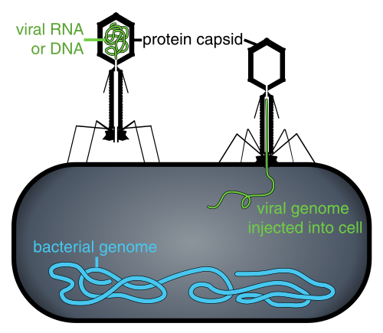
Figure 1. Schematic diagram of a virus invading a cell.
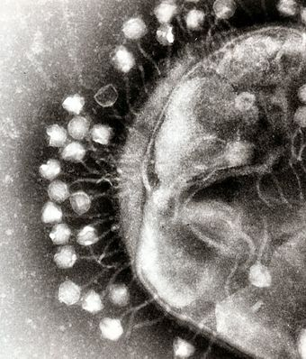
Figure 1. Illustration of a virus invading a cell.
Copyright © 2020, Louis Kauffman and Joel Isaacson. All rights reserved.
Editors Notes: Dr. Joel Isaacson and Dr. Louis Kauffman have been the leading scientists for the discovery and research for Recursive Distinctioning, Many of their publications can be found in issues of the Journal of Space Philosophy. Kepler Space Institute (KSI) will host the 5th Annual Recursive Distinctioning Conference, virtual, May 9th and 10th, 2020. This publication is occurring at the peak if the COVID-19 Pandemic global crisis. Readers should note The following Kauffman – Isaacson quote on page 40:
“In the full complexity of molecular biology, we have not only the fantastic workings of the cells, but also the diabolical workings of the virus, where a molecular object has only parasitic existence and depends for its livelihood on interaction with a cell as environment for its viral DNA. Here again we have a powerful RD variant where an entity (the virus) can engage in key –in-lock interaction with cellular membranes in order to use the cellular environment for its individual recursion and self production (Figures 1 and 2)”.
Bob Krone and Gordon Arthur.

www.dropbox.com/s/tkkye8g99tzm0xm/RDL.pdf?dl=0.
en.wikipedia.org/wiki/Highlife_(cellular_automaton).
www.dropbox.com/s/zm785d20bma6tb2/KauffmanExcerpt.pdf?dl=0.
See the Special Issue of the Journal of Space Philosophy (vol. 5, no. 1; Spring 2016) devoted to RD.
See homepages.math.uic.edu/~kauffman/ArithForm.pdf for more information about this system and its relationship with binary representations of numbers.

